AI-ASSISTED CODING
ASSIGNMENT-15.3
Backend API Development: Creating RESTful Services with AI
NAME: Adepu Goutham Sri Bhargav
HALL-TICKET: 2403A510C4
BATCH NO: 05

TASK-1:
Ask AI to generate a Flask REST API with one route:
GET /hello → returns {"message": "Hello, AI Coding!"}
Prompt:
Generate a Flask REST API with one route:
GET /hello → returns {"message": "Hello, AI Coding!"}
CODE GENERATED:
from flask import Flask, jsonify

app = Flask(__name__)

@app.route('/hello', methods=['GET'])
def hello():
return jsonify({"message": "Hello, AI Coding!"})

if __name__ == '__main__':
app.run(debug=True)

OUTPUT(terminal and website):
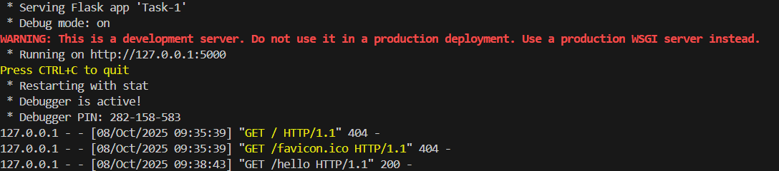
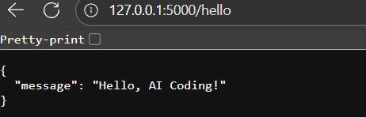

OBSERVATION :
The Flask REST API runs successfully and responds correctly when accessed at /hello. It returns a JSON message {"message": "Hello, AI Coding!"}, confirming that the route and server setup work as expected.

TASK -2:
Use AI to build REST endpoints for a Student API:
• GET /students → List all students.
• POST /students → Add a new student.
• PUT /students/<id> → Update student details.
• DELETE /students/<id> → Delete a student.
PROMPT:
Build a Flask REST API for managing students with the following endpoints:
• GET /students → List all students.
• POST /students → Add a new student.
• PUT /students/<id> → Update student details.
• DELETE /students/<id> → Delete a student.

CODE GENERATED:
from flask import Flask, jsonify, request

app = Flask(__name__)

# In-memory storage
students = [
{"id": 1, "name": "Alice", "age": 20},
{"id": 2, "name": "Bob", "age": 22}
]

# GET /students → List all students
@app.route('/students', methods=['GET'])
def get_students():
return jsonify(students), 200

# POST /students → Add a new student
@app.route('/students', methods=['POST'])
def add_student():
data = request.get_json()
new_id = max(s["id"] for s in students) + 1 if students else 1
new_student = {
"id": new_id,
"name": data.get("name"),
"age": data.get("age")
}
students.append(new_student)
return jsonify({"message": "Student added successfully!", "student": new_student}), 201

# PUT /students/<id> → Update student details
@app.route('/students/<int:student_id>', methods=['PUT'])
def update_student(student_id):
data = request.get_json()
for student in students:
if student["id"] == student_id:
student["name"] = data.get("name", student["name"])
student["age"] = data.get("age", student["age"])
return jsonify({"message": "Student updated successfully!", "student": student}), 200
return jsonify({"error": "Student not found"}), 404

# DELETE /students/<id> → Delete a student
@app.route('/students/<int:student_id>', methods=['DELETE'])
def delete_student(student_id):
for student in students:
if student["id"] == student_id:
students.remove(student)
return jsonify({"message": "Student deleted successfully!"}), 200
return jsonify({"error": "Student not found"}), 404

if __name__ == '__main__':
app.run(debug=True)

OUTPUT:
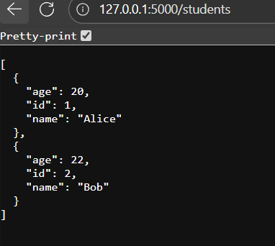
OBSERVATION:
The Student API works successfully with CRUD operations using Flask. Each endpoint returns appropriate JSON responses, and the in-memory list acts as temporary storage for student data.

TASK – 3:
Ask AI to generate a REST API endpoint
PROMPT:
Generate a Flask REST API with a /search endpoint that takes a query parameter name, searches a list of students, and returns matching results in JSON format. Include code that handles when no query or no matches are found.

CODE GENERATED:
from flask import Flask, request, jsonify

app = Flask(__name__)

# Sample data
students = [
{"id": 1, "name": "Alice"},
{"id": 2, "name": "Bob"},
{"id": 3, "name": "Charlie"},
{"id": 4, "name": "Alicia"}
]

# GET /search?name=<query>
@app.route('/search', methods=['GET'])
def search_students():
query = request.args.get('name', '').lower()

if not query:
return jsonify({"error": "Please provide a 'name' query parameter."}), 400

results = [s for s in students if query in s['name'].lower()]

if not results:
return jsonify({"message": "No matching students found."}), 404

return jsonify({"results": results}), 200

if __name__ == '__main__':
app.run(debug=True)
from flask import Flask, request, jsonify

app = Flask(__name__)

# Sample data
students = [
{"id": 1, "name": "Alice"},
{"id": 2, "name": "Bob"},
{"id": 3, "name": "Charlie"},
{"id": 4, "name": "Alicia"}
]

# GET /search?name=<query>
@app.route('/search', methods=['GET'])
def search_students():
query = request.args.get('name', '').lower()

if not query:
return jsonify({"error": "Please provide a 'name' query parameter."}), 400

results = [s for s in students if query in s['name'].lower()]

if not results:
return jsonify({"message": "No matching students found."}), 404

return jsonify({"results": results}), 200

if __name__ == '__main__':
app.run(debug=True)

OUTPUT:
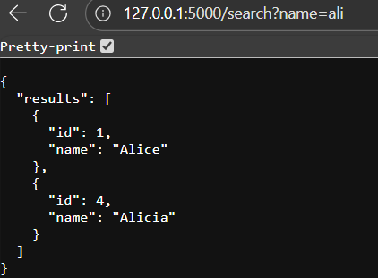

OBSERVATION:
The /search endpoint works correctly by taking a query parameter, filtering matching student names, and returning results in JSON format. It also handles cases with no query or no matches gracefully.
TASK – 4:
ask AI to write test scripts using Python requests module to call
APIs created above.
PROMPT:
write Python test scripts using the requests module to call the Flask APIs created earlier.
CODE GENERATED:
import urllib.request
import urllib.parse
import json

BASE_URL = "http://127.0.0.1:5000"

def print_response(resp):
data = resp.read().decode()
try:
print(json.dumps(json.loads(data), indent=2))
except:
print(data)
print("-" * 40)

# 1. GET /students
print("GET /students")
resp = urllib.request.urlopen(f"{BASE_URL}/students")
print_response(resp)

# 2. POST /students
print("POST /students")
student = {"name": "David", "age": 23}
data = json.dumps(student).encode("utf-8")
req = urllib.request.Request(f"{BASE_URL}/students", data=data, headers={"Content-Type": "application/json"})
resp = urllib.request.urlopen(req)
print_response(resp)

# 3. PUT /students/1
print("PUT /students/1")
update_data = {"name": "Alice Updated", "age": 21}
data = json.dumps(update_data).encode("utf-8")
req = urllib.request.Request(f"{BASE_URL}/students/1", data=data, headers={"Content-Type": "application/json"}, method="PUT")
resp = urllib.request.urlopen(req)
print_response(resp)

# 4. DELETE /students/2
print("DELETE /students/2")
req = urllib.request.Request(f"{BASE_URL}/students/2", method="DELETE")
resp = urllib.request.urlopen(req)
print_response(resp)

# 5. GET /search?name=ali
print("GET /search?name=ali")
query = urllib.parse.urlencode({"name": "ali"})
resp = urllib.request.urlopen(f"{BASE_URL}/search?{query}")
print_response(resp)

OUTPUT:

OBSERVATION:
The test script successfully calls all Flask API endpoints using Python’s built-in modules. It handles GET, POST, PUT, DELETE, and query parameters, returning clear JSON responses without requiring any external libraries.

